Asiqul Hoque

Homework12

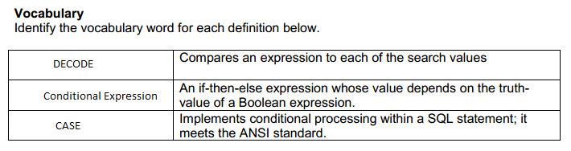

1. select title,DECODE(duration,'2 min', 'shortest','10 min', 'longest') as "Play Times"

from d_songs;

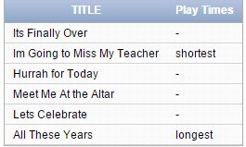

2. select department_id, last_name, salary,CASE department_id

WHEN 10 then 1.25 * salary

WHEN 90 then 1.5 * salary

WHEN 130 then 1.75 * salary

ELSE salary

END AS "New Salary"

from employees;

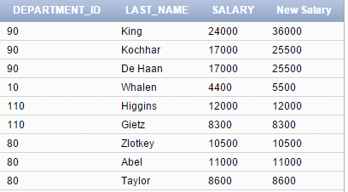

3. select first_name, last_name, manager_ID, commission_pct,

CASE WHEN manager_id IS NULL THEN commission_pct

ELSE COALESCE(commission_pct, 99999)

END as "Review"

from employees

where department_id in(80, 90);

